**How to describe a film poster**

at

in

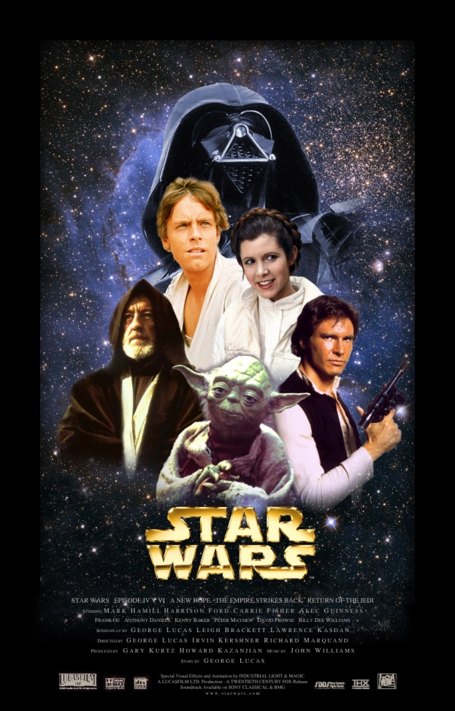

the

at

in

in

the

the

1- Describe the composition of the poster, its structure, the light and the colours.

2- What catches your eye first?

3- Describe the different elements. What can you see. Is there action? What are the people doing?

4- What are your impressions? What can you imagine about the story?

**Look at these posters. Are they different or similar?**

